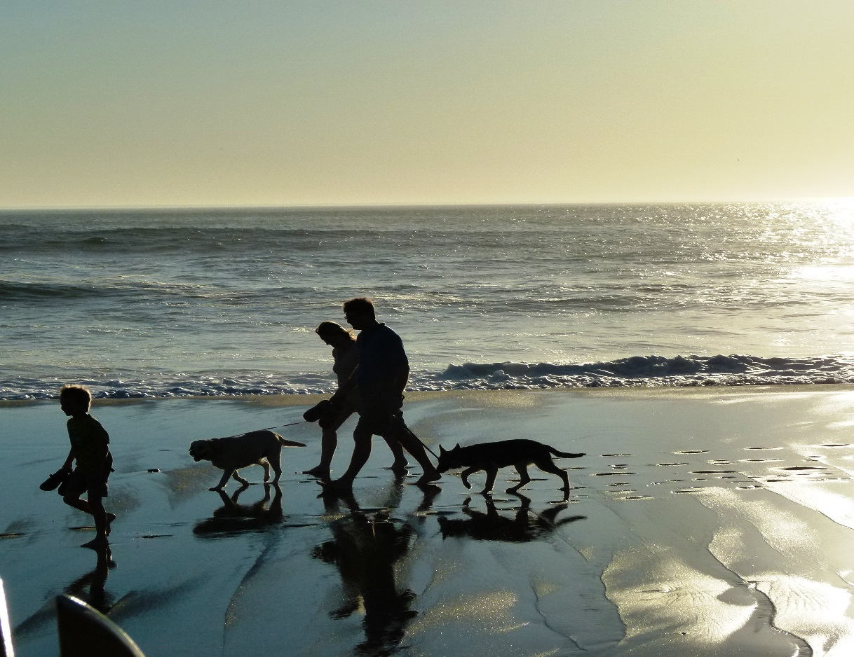 |  | - December 2014
  Where to Stay
  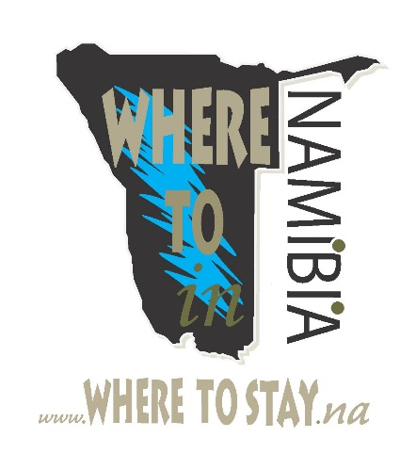
Benguela Coastline |  | In This Issue
Internal Marketing
Why Namibia ?
Social Media
What’s On

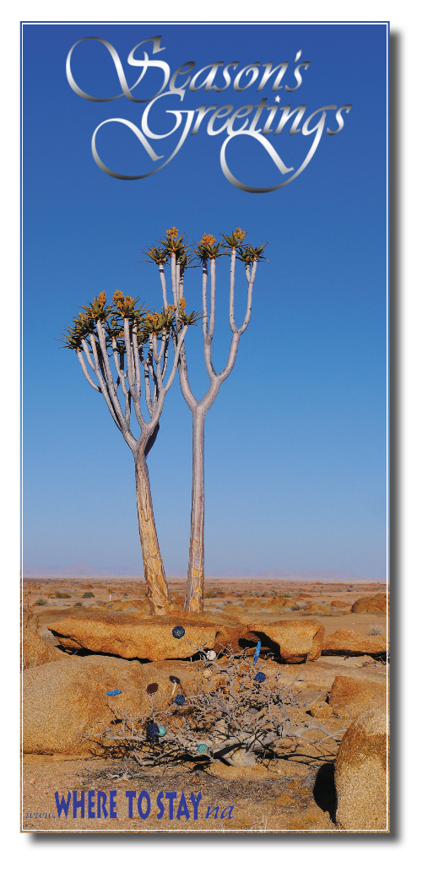

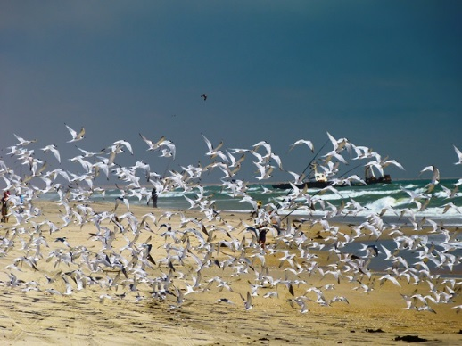

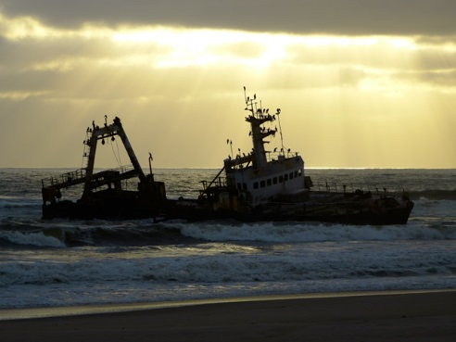
“IN THE DIGITAL WORLD, HE WHO HESITATES IS ABANDONED. SO YOU HAVE TO GENERATE 3 D EXCITEMENT WITH AS MANY DEVICES AS YOU CAN FIND” Howard Stringer

Page 2

Featuring our Benguela Coastline
Namibia has been growing in popularity as a tourist destination, although we doesn’t have a warm coastline to attract sun-loving beach-goers.
Generally, tourists come for self-drive holidays or tours in small groups. This allows visitors to enjoy the isolated nature of many attractions

Page 3
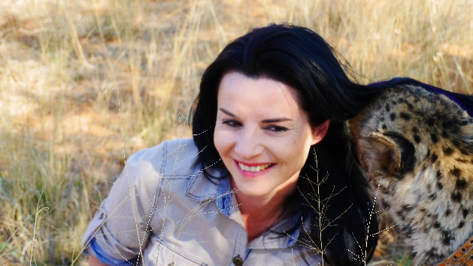
The impact of social media platforms in the travel and tourism industry is becoming more pervasive, given the popularity of sharing travel aspirations and experiences amongst their users. Social networks can be very influential when it comes to purchase decisions, and this trend is particularly notable within the travel industry. Therefore, it is important to consider the use of social media and how travelers interact with the various platforms at different stages of their travel planning.

Social Media
by Estell Hansen

CHOICES, CHOICES ►DESTINATION
Share ►Like ►g+

“KEEP it real”

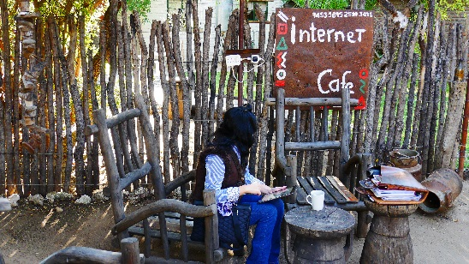
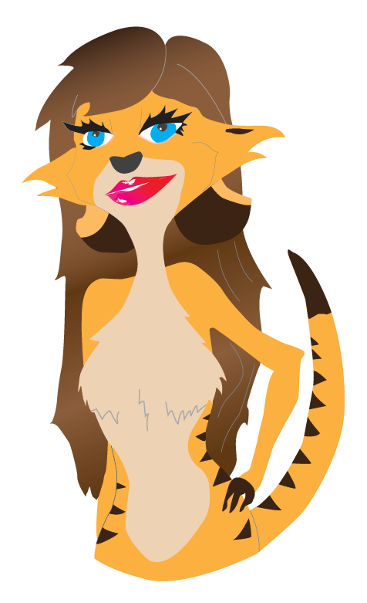

We all want to “share” or rather, belong.
by Suri

INSPIRING TRAVEL PLANNING
Approximately one-fifth of traveller’s worldwide turn to social media for inspiration during their travel planning, the highest reference being taken for selecting a destination.

 |  |  |  |  |  | 
In social psychology, the need to belong is an intrinsic motivation to affiliate with others and be socially accepted. This need plays a role in a number of social phenomena such as self-presentation and social comparison.
Our need to belong is what drives us to seek out relationships with other people. It also motivates us to participate in social activities such as clubs, sports teams, religious groups etc. By belonging to a group, we feel as if we are a part of something bigger and more important than ourselves. Therefore SOCIAL MEDIA.

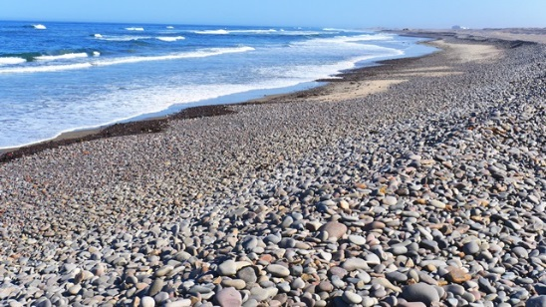
Skeleton Coast

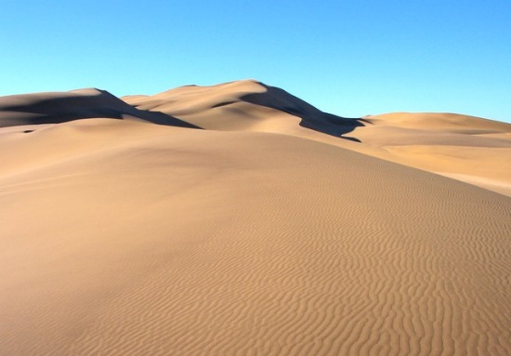
Namib Dunes

Fast Facts

The Benguela Current Echo system of Southern –Africa is the strongest wind-driven coastal upwelling system in the world
100% Namibia has become what is thought to be the first country to designate its entire coastline a national park.

Where @ the coast
Printed & Digital Guide on Coastal: ►Stay ► Dine ► Do ►Buy & More.

Benguela Coastline by Daan Roux

From the diamond-rich Sperrgebiet in the south to the inhospitable coastline of the Skeleton Coast, the Namibian coastline along the cold Atlantic Ocean is an ideal holiday and tourist destination.
Both shore fishing and boat fishing are rated amongst the best in the world. Walvis Bay is seen as the gateway to central and Southern Africa due to its port. A natural lagoon, which is a RAMSAR protected site, hosts thousands of flamingoes and other sea birds.
In the vibrant harbour of Lüderitz fishing boats are unloading the daily caught fish. This jewel in the desert has experienced a recent revival with its developing waterfront.
The Namib Desert exhibits astounding plant, insect and animal life that have uniquely adapted to this age-old landscape of sand. The Atlantic Ocean exhibits interesting marine excursions, e.g. boat cruises, kayak rowing, surf & boat angling.
One of the main attractions of Namibia's coast is its outstanding angling potential, whether from the beach or off small boats, and diving for rock lobster. Popular species are kabeljou, galjoen, blacktail, steenbras, geelbek and white stumpnose. The main angling season is from November to March, and as these are also the hottest months in the interior, Namibians depart in large numbers to the coast to enjoy the cool



climate created by the Atlantic's cold Benguela Current.
The coastal towns offer many different types of accommodation facilities.
Swakopmund has several large hotels and a casino, hotel pensions which offer bed and breakfast, a large complex of different-sized bungalows specifically geared to accommodate anglers, small secluded guest houses and holiday flats fully equipped for self-caterers. The town has a large choice of excellent restaurants and shops where Namibian arts and crafts can be bought. These include hand-crafted jewellery, karakul rugs and carpets, leather goods such as the popular "Swakopmunder", a shoe made from kudu hide, and basketry from the north.

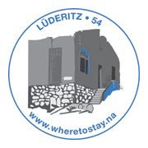
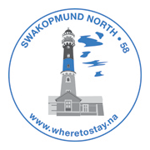
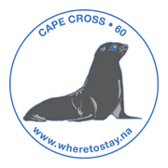

Cape Cross
“In the year 6685 after the creation of the world and 1485 after the birth of Christ, the brilliant, far-sighted King John II of Portugal ordered Diogo Cão, knight of his court, to discover this land and to erect this padrão here”. ”
Today Cape Cross is a protected area owned by the government of Namibia under the name Cape Cross Seal Reserve. The reserve is the home of one of the largest colonies of Cape Fur Seals in the world.
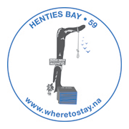

Henties Bay
Henties Bay is situated along the National West Coast Recreation Area and can be reached by the C34 salt road via Swakopmund or the D1913 gravel road via the Spitzkoppe. It is a popular angling resort and an excellent base from where to explore the Namib Desert. The magnificent coastline is decorated with beautiful uncrowded beaches and secluded bays to explore. Galjoen, steenbras, rock lobster and dassie are amongst the most common species found in these waters.
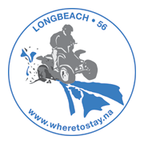Long Beach
Long Beach, a popular holiday resort, is situated between Swakopmund and Walvis Bay and offers restaurants, tidal pools for the children, playgrounds as well as fishing and crayfishing during season. Many tours are offered on and around Long Beach.
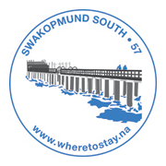
Swakopmund
Visiting Namibia's premier holiday resort is a tourism highlight. Swakopmund, lovingly nicknamed "Sleeping Beauty" as it is frequently enveloped in mist, is an ideal location for the visitor who wants to explore both the desert and the coast. Most visitors soon realise that they have allocated too little time to experience the many interesting sites this region offers.
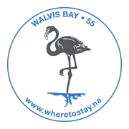Walvis Bay
Walvis Bay has capitalised on its well-endowed natural resources and scenic beauty. There is much to discover, learn, enjoy and appreciate. Visitors are treated with friendliness and every effort is made to ensure that they are comfortable - an unforgettable experience.
One of the key attractions of this town is the remarkable natural lagoon. This tranquil stretch of water with its natural beauty is accentuated by thousands of flamingoes and other birds.
A place of rare beauty and windswept dunes, stark landscapes and jagged coastlines - a world of untamed natural beauty. Walvis Bay is situated on the south-west coast of Africa at the edge of the Namib Desert and is Namibia's principal port and growth centre.
Walvis Bay's rich natural resources and strategic location provide the basis for tourism and industrial development. The existing environment of growth and prosperity has already contributed to unprecedented interest both nationally and internationally. Seen as the gateway to central and southern Africa, Walvis Bay is on the threshold of a prosperous and dynamic future.
Lüderitz

Lüderitz was named after Adolf Lüderitz, who started a trading station in 1883.
Diamonds were discovered in the early 1900's and due to the great diamond boom, the luxurious town of Kolmanskop was built, today a ghost town. Later, more diamonds and a richer field were found further south and it was then that Kolmanskop was deserted and became the ghost town as it is today.
Lüderitz itself is a lovely town renowned for its old world charm and distinct German architecture. LÃ¼deritz offers a variety of excellent restaurants, especially for seafood lovers and you will experience the true warm & friendly hospitality of this town.
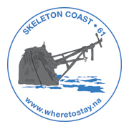Skeleton Coast
The Bushmen of the Namibian interior called the region "The Land God Made in Anger", while Portuguese sailors once referred to it as "The Gates of Hell".
On the coast the upwelling of the cold Benguela current gives rise to dense ocean fogs (called "cassimbo" by the Angolans) for much of the year. There is a constant, heavy surf on the beaches.
Namibia has declared the 16,000 square kilometres (6,200 sq. mi) Skeleton Coast National Park over much of the area, from the Ugab River to the Kunene.

